**CMOS D-flip-flop**

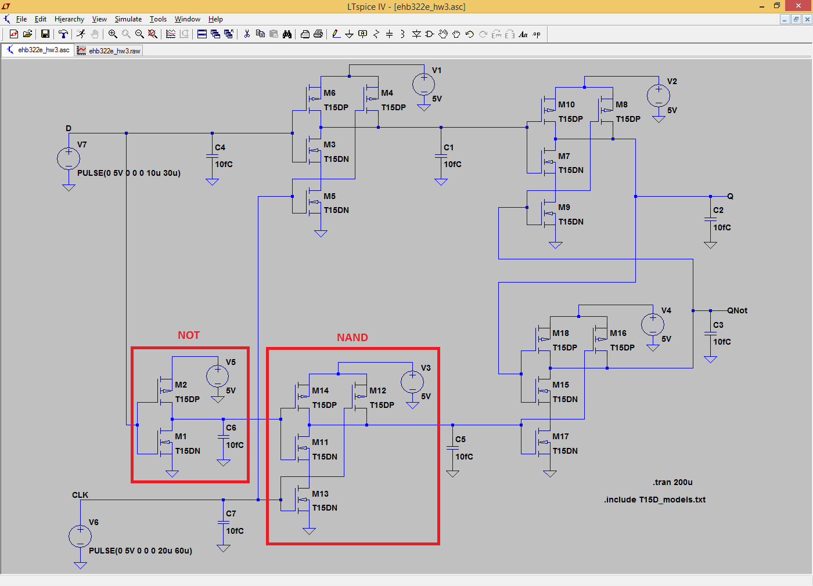

**Q output with D and CLK**

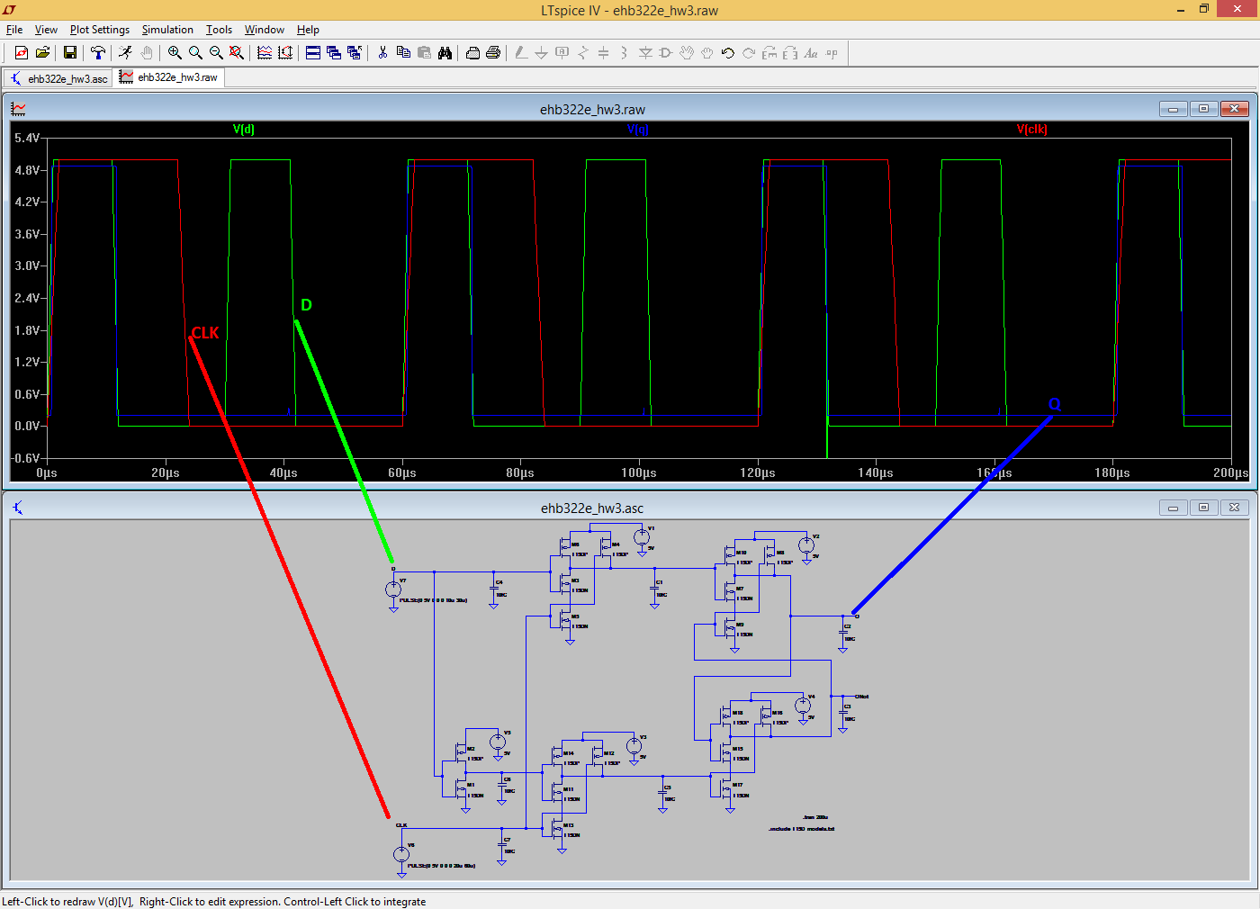

**W.C. PD at Q with D input**

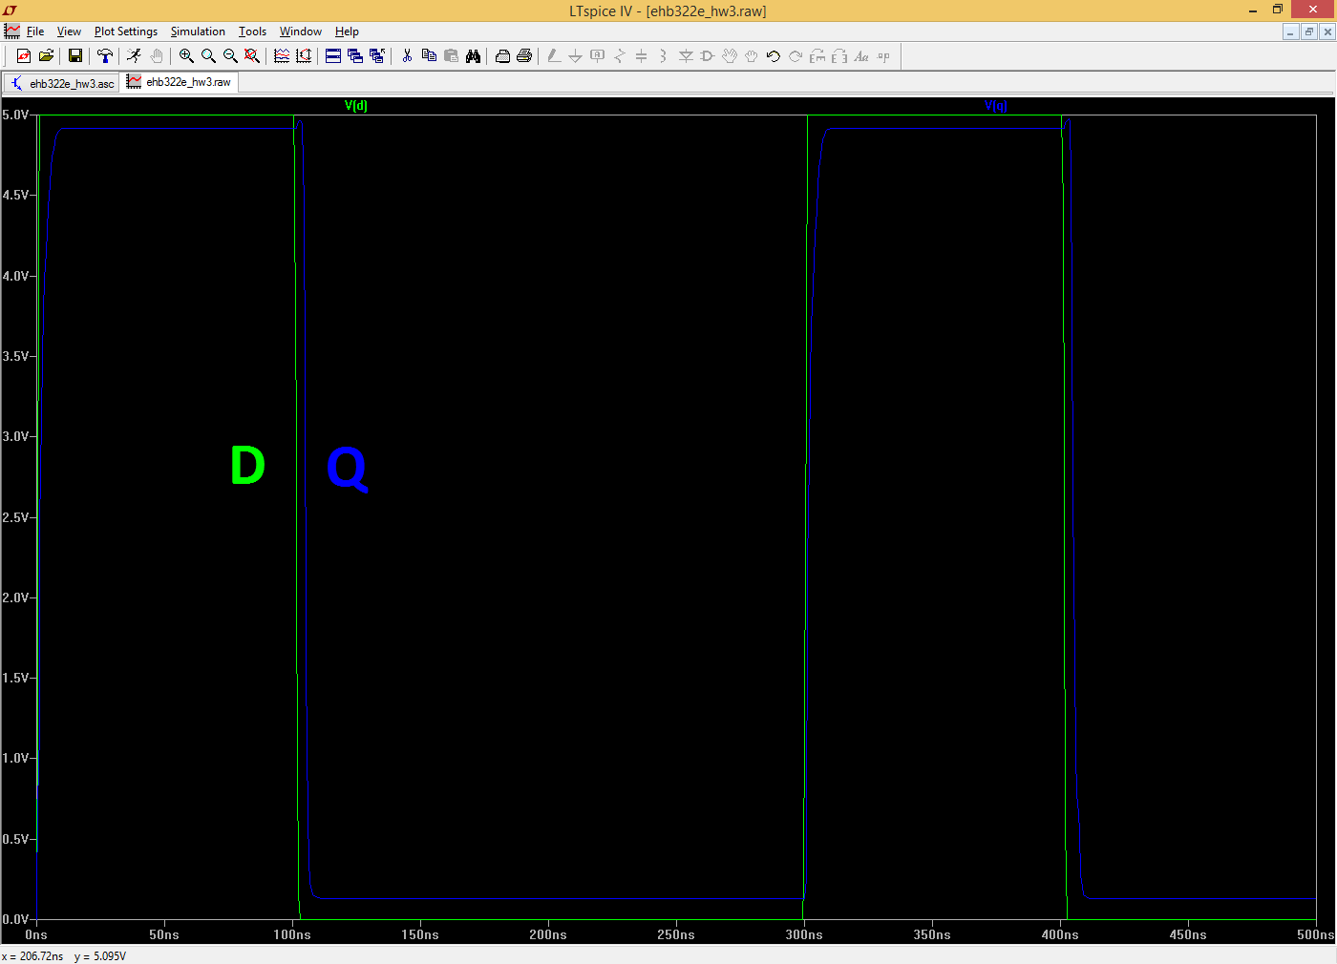

**W.C. Total tPHL at Q with D input**

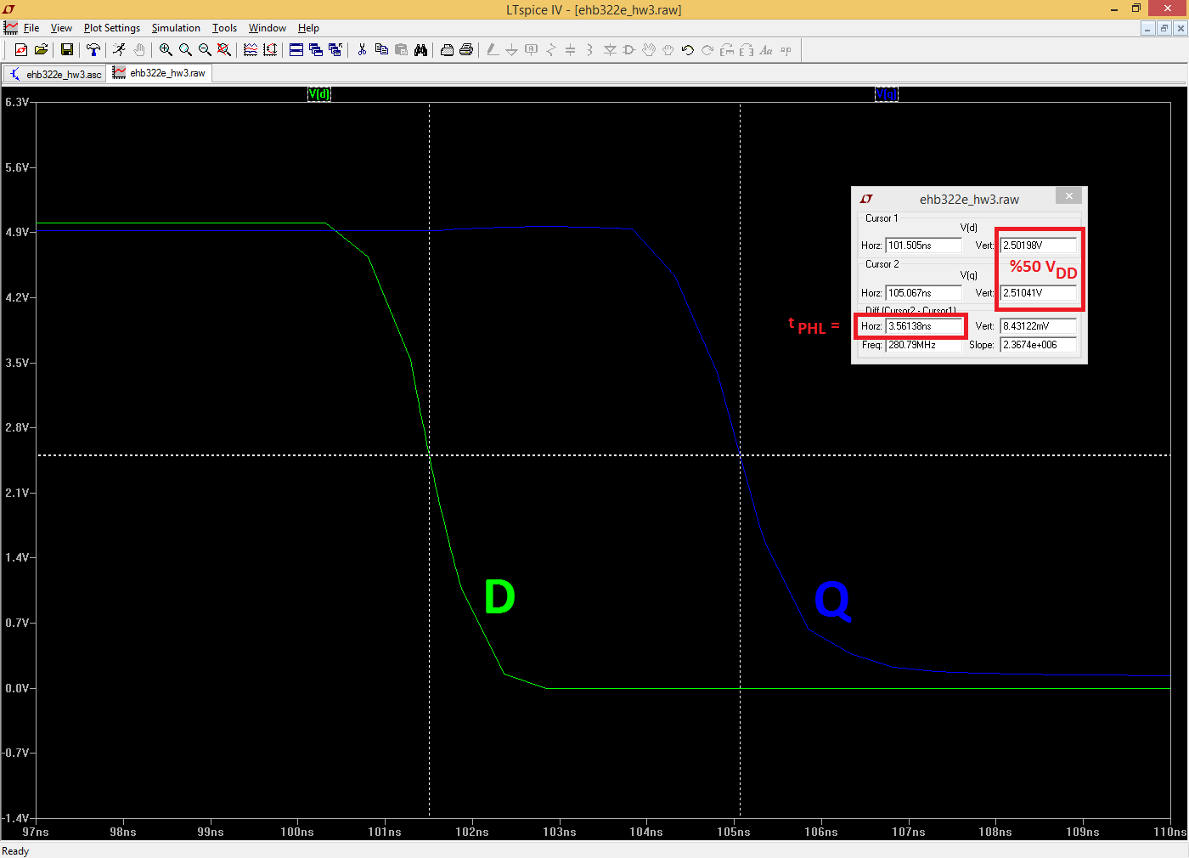

**W.C. Toltal tPLH at Q with D input**

